Chapter 19: Survival analysis – the time before events
The Kaplan Meier Survival Function
Consider a cohort of 20 participants who are 65 years of age and older, monitored for up to 24 years. Censoring occurs either when the study ends or they are lost to follow-up.
Load the data (Elder Mortality.csv) and analyze the Kaplan-Meier curve.
Year | Death
1 | Dead
2 | Censored
3 | Dead
5 | Dead
6 | Censored
8 | Dead
9 | Censored
10 | Censored
12 | Censored
13 | Censored
14 | Dead
16 | Dead
17 | Dead
18 | Censored
19 | Censored
20 | Dead
21 | Censored
22 | Dead
23 | Dead
24 | Censored

library(survival)
library(car)
file = read.csv("Elder Mortality.csv")

file$time = file$Year
file$event = Recode(file$Death, " 'Dead' = 1;
'Censored' = 0 ", as.factor=FALSE, as.numeric=TRUE)

Perform the file management, as above. After that, simply follow the coding instructions given in the book for a single group (in the code, starting with 'unigroup').

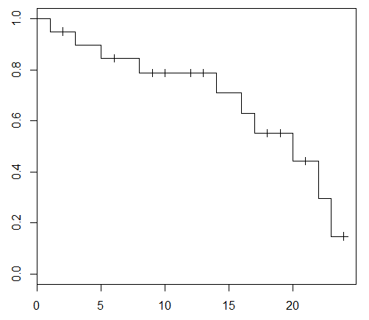

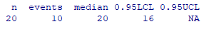
The median survival time is 20 years. This means that on the 20th year, half of the participants have already died or lost contact while the other half are still going on with the study. The curve shows an acceleration in deaths later on.

