Descriptive Statistics
Exercises for central tendency and dispersion
Open the Height and Weight Data.csv file in R.
> file = read.csv("Height and Weight Data.csv") # reads file
> HtWt = with(file, data.frame(height, weight)) # data frames are useful for many tests
> HtWt = na.omit(HtWt) # removes missing data

- Calculate descriptive statistics (mean, median, range) for two variables, height and weight.
You could use something like this:
> mean(HtWt$weight)
[1] 65.8
and do the same with median() and range(). And then do it all again for HtWt$height.

This is quicker:
> library(psych)
> describe(HtWt)

vars n mean sd median trimmed mad min max range skew kurtosis
height 1 200 170.02 12.01 169.5 170.32 9.64 57 197 140 -4.00 37.07
weight 2 200 65.80 15.10 63.0 64.21 11.86 39 166 127 2.01 8.96
se
height 0.85
weight 1.07

Or
> summary(HtWt)
height weight
Min. : 57.0 Min. : 39.0
1st Qu.:164.0 1st Qu.: 55.0
Median :169.5 Median : 63.0
Mean :170.0 Mean : 65.8
3rd Qu.:177.2 3rd Qu.: 74.0
Max. :197.0 Max. :166.0

- Split the data by 'Sex' and calculate the same descriptive statistics. It is suggested that you look up the Psych library's describeBy function.
> HtWtSex = with(file, data.frame(height, weight, sex)) # includes 'sex' variable
> library(psych)
> describeBy(HtWtSx, HtWtSex$sex)

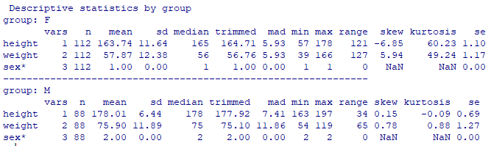

- Produce histograms for the height and weight variables and decide if the distribution shapes resemble that of the Gaussian distribution. It is suggested that you use the hist() function.

> hist(HtWtSx$height)
> hist(HtWtSx$weight)

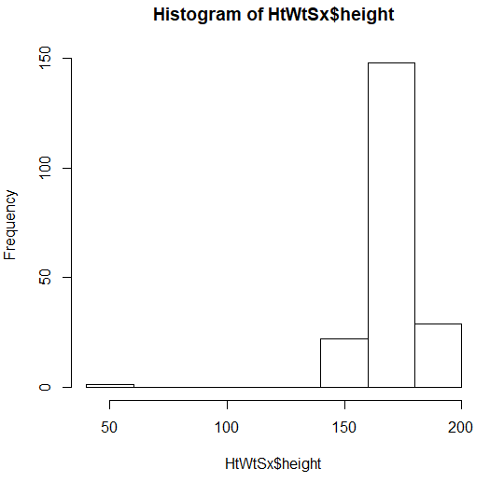

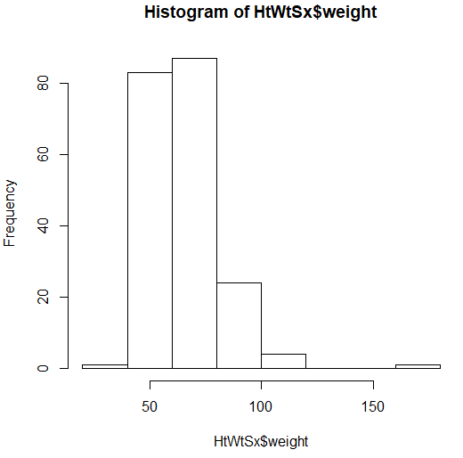

These do not resemble a Gaussian distribution.

