Null hypothesis significance testing
Given a data set of self-reports of height and weight (use the Height and Weight Data.csv file), use a t test to assess the null hypothesis that the mean weight of male respondents is equal to the mean weight of female respondents.
H0: $Mean weight of males= Mean weight of females$
If you have not yet learned to use t tests (in the Tests of Differences chapter):

> file = read.csv("Height and Weight Data.csv")
> wtGender = with(file, data.frame(weight, sex)) # weight is the dependent variable, sex the grouping
> wtGender = na.omit(sentence)

> shapiro.test(wtGender$weight) # a test of normality
Shapiro-Wilk normality test

data: wtGender$weight
W = 0.87074, p-value = 4.919e-12

We have no reason to reject the null hypothesis, of normality of the dependent variable

> summary(wtGender)
weight sex
Min. : 39.0 F :112
1st Qu. : 55.0 M: 88
Median : 63.0
Mean : 65.8
3rd Qu.: 74.0
Max. :166.0

> wtGender$weight; sex = wtGender$sex # making for easier coding for tests
> options(scipen = 999, digits = 3) # removes scientific notation

There is rather an imbalance between the number of males and females in the samples. So instead of using the usual t test (otherwise known as Student's t test) – which would be
t.test(weight ~ sex, paired=FALSE, var.equal=TRUE) # dependent variable attached by ~ to factor
- we'll use Welch's t test:
> t.test(weight ~ sex, var.equal=FALSE)

Welch Two Sample t-test

data: weight by sex
t = -10, df = 200, p-value <0.0000000000000002
alternative hypothesis: true difference in means is not equal to 0
95 percent confidence interval:
-21.4 -14.6
sample estimates:
mean in group F mean in group M
57.9 75.9

Show your analysis of these results. You may also want to use the describeBy function, as in the exercise for the previous chapter (descriptive statistics).

The group means (shown at the bottom of the t test read-out) show that the mean weight of males is considerably higher than the mean weight of females.
Since the significance value) is (considerably) lower than the critical value 0.05, we have evidence to reject the null hypothesis that males and females have equal mean weight. (Very similar results will be found if you use the other t test.)

> library(psych)
> describeBy(weight, sex)

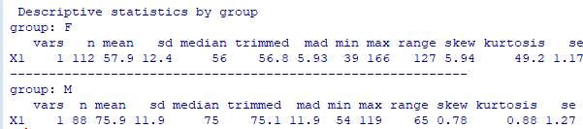

This method gives a lot more detail. If the data is not normal and you use the Wilcoxon, the median would be a better statistic to cite. In formal reports, you may also want to use 'sd' (standard deviation).

