Chapter 10
Repeated measures two-way ANOVA
The behavior of prisoners with known drug abuse problems is monitored; averaged ratings are on a scale of 1 to 10, 1 being particularly disruptive and 10 the most well-behaved. The two factors under consideration are whether or not the prisoners are in lockdown, and whether or not they are offered a drug substitute.
Perform a repeated measures two-way ANOVA in JASP to analyze the individual and interaction effects of lockdown and the provision of a substitute drug. Use the Repeated-measures two-way ANOVA csv file.
LockdownSubstance | LockdownSubstance | NolockdownSubstance | NolockdownNosubstance
6 | 5 | 9 | 7
9 | 6 | 6 | 4
5 | 3 | 8 | 5
6 | 2 | 5 | 5
6 | 5 | 9 | 6
3 | 3 | 7 | 5
9 | 6 | 7 | 5
4 | 2 | 4 | 3
8 | 5 | 6 | 5
7 | 2 | 8 | 4

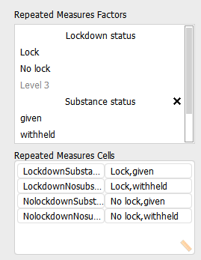

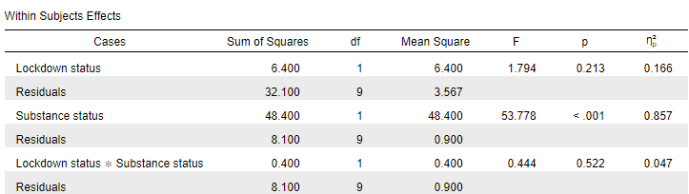
The results show that only Substance status has a significant effect since its p value is less than 0.05. In addition, it has a very large effect size (use 'Estimates of effect size' to find this). The interaction effect and Lockdown status effect are insignificant.
Between-Subjects ANOVA
Members of the public are asked how safe they feel from crimes of violence. The results are broken down according to social class and environs. Class: 1 = poor, 2 = working class, 3 = middle class, 4 = upper middle/upper class. Environs: 1 = urban, 2 = suburban, 3 = rural
The results are as follows (in the Between Subjects ANOVA csv file):
Perceived safety | Class | Environs
109 | 1 | 1
110 | 1 | 1
110 | 1 | 2
112 | 1 | 2
116 | 1 | 3
114 | 1 | 3
110 | 2 | 1
115 | 2 | 1
110 | 2 | 2
111 | 2 | 2
112 | 2 | 3
115 | 2 | 3
108 | 3 | 1
109 | 3 | 1
111 | 3 | 2
109 | 3 | 2
114 | 3 | 3
119 | 3 | 3
110 | 4 | 1
108 | 4 | 1
114 | 4 | 2
112 | 4 | 2
120 | 4 | 3
117 | 4 | 3

Test to see if there is a difference in the safety perception scores according to the factors considered.
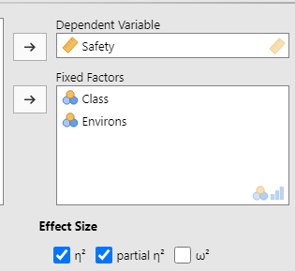
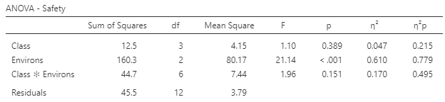
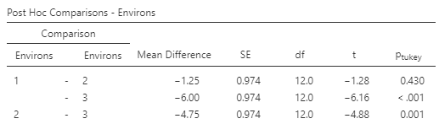

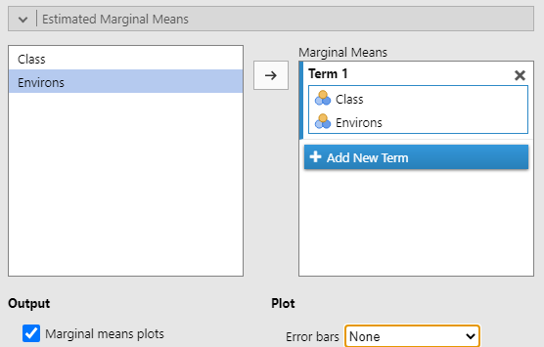
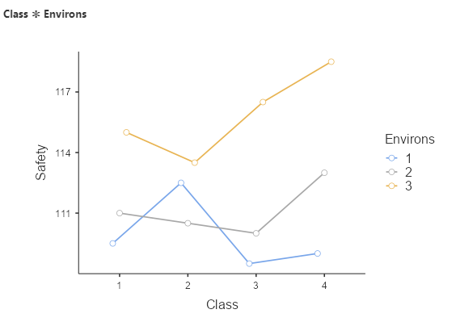
The ANOVA results show that the Safety score differs based upon the environs (the p value is lower than 0.05). Moreover, this has a very large effect size at 0.779. Since there are three categories of environs, a post hoc test may be useful: environs 1 and 3 (urban and rural) as well as 2 and 3 (suburban and rural) have significantly different effects on the scale. As shown in the plot, environment 3 (rural) appears to elicit the highest Safety score on all of the environs. (Spoiler alert: fictional study, as usual.)
Mixed ANOVA
In this (completely imaginary) study, Judges are asked to rate the quality of the arguments presented by the lawyers prosecuting and defending defendants; the evidence of several cases is averaged in order to eradicate factors such as time. Of particular importance is thought to be the level of the court: lay members are at level 1; professional judges in lower courts are at level 2; senior courts are level 1.

Judge | Court level | Defence | Prosecution
1 | 3 | 23 | 24
2 | 3 | 24 | 23
3 | 3 | 25 | 28
4 | 2 | 30 | 38
5 | 2 | 28 | 36
6 | 2 | 26 | 35
7 | 1 | 31 | 34
8 | 1 | 32 | 36
9 | 1 | 29 | 39

Conduct a mixed ANOVA with JASP, using the Mixed ANOVA csv file, and identify which factors are associated with judicial credibility.
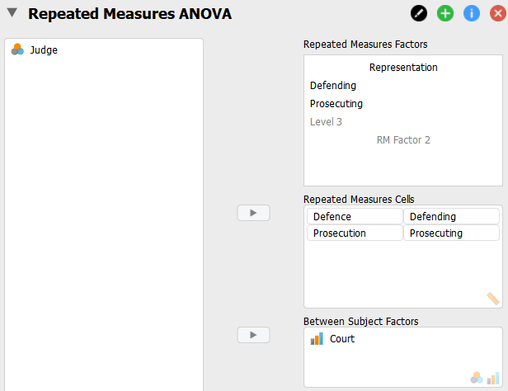
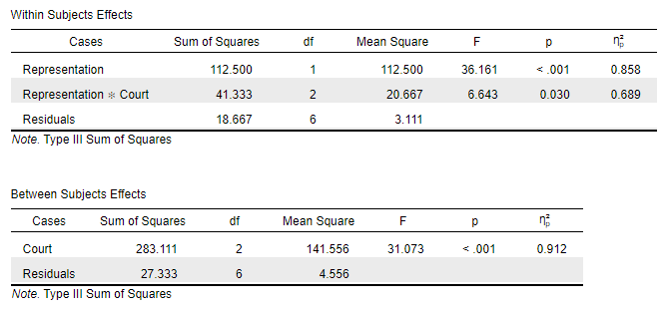

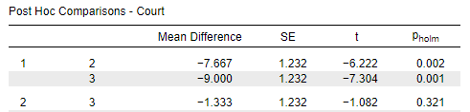

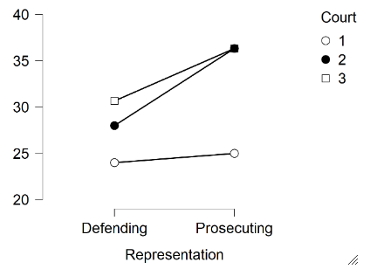

The within subject and between subject effects are both significant, as is their interaction. Moreover, they have large effect sizes (partial eta squared has been used). The post hoc tests indicate differences between court levels 1 and 2, and between court levels 1 and 3 (the most senior courts, level 1, seem to differ from the lower courts).
The descriptives plot shows that on consideration of both defending and prosecuting lawyers, court level 1 (the most senior court) produces the lowest average score. Court level 3 has a higher average score than court level 2 relating to the defence, but there was no clear difference between them in consideration of prosecution cases.

