Chapter 11
ANCOVA
The Sentence.csv file examines differences between prisoners from three different offending categories: white collar, theft and violence. The length of sentence is one scale. The others are the extents of religiosity, literacy and family conflict. (This study is a fictional one, as usual, based on the Iris data set.)
We are interested here in whether or not length of sentence tends to differ according to the type of conviction. Let us assume that the researchers consider that religiosity is considered to be a cause of confusion, and we would like to have the 'Religiosity' scale taken into consideration as a potential cause of noise.

Check the assumptions before reporting the results but for simplicity, report the results 'as is' even though some assumptions may be violated. No data transformation will be conducted.
Set up ANCOVA as shown in the book, with Sentence as the dependent variable, Offence as the factor and Religiosity as a covariate. The following options are suggested:
- Homogeneity tests
- Normality (Q-Q plot)
- Post hoc tests for Offence (Tukey)
- Estimated marginal means section:
  - Offence in 'Term 1'
  - Marginal Means plots
  - Equal cell weights
  - Error bars, confidence intervals option
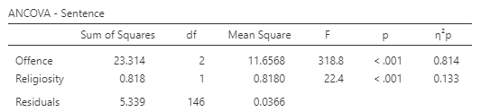
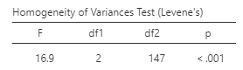

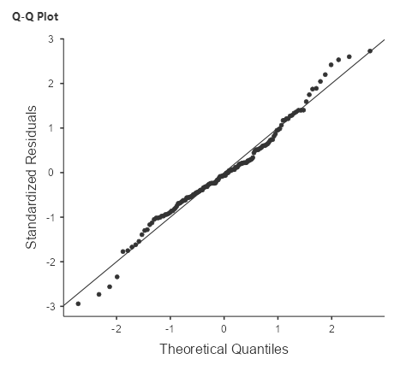

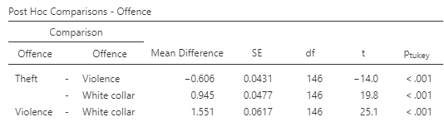

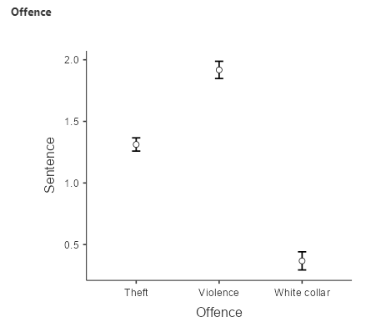

State the null and alternative hypotheses:
H0: The average prison sentence is the same for all conviction categories controlling for Religiosity
H1: The average prison sentence differs between at least two types of criminal conviction controlling for Religiosity
What do the assumption results show?
The Levene’s Test statistic is significant (p <.05). Thus, the assumption of equality of variance was not met.
The normal Q-Q plot shows a satisfactory result. The standardized residuals plotted against their quantiles do not deviate from the normal line.
What do the ANCOVA results show?
The ANCOVA test shows a significant result both for the conviction categories and Religiosity.
What is the result of a post-hoc test to identify significant differences among conviction categories?
There are significant differences in sentence duration between every conviction category.

