Chapter 13: PCA and Factor Analysis
PCA
Open the Girls.csv data file in Jamovi. This is an imaginary study about teenage girls' reluctance to participate in school sports, based on interview ratings and surveys. At this stage, assume that we have no underlying theory.
The variable headers are:
interest, agility, contact, strength, clothes, looks, internal, speed, teacher, masculine, harassment

Conduct a Principal Components Analysis (PCA) to reduce the number of variables that describe the characteristics.
Describe the assumption test results and the PCA results.

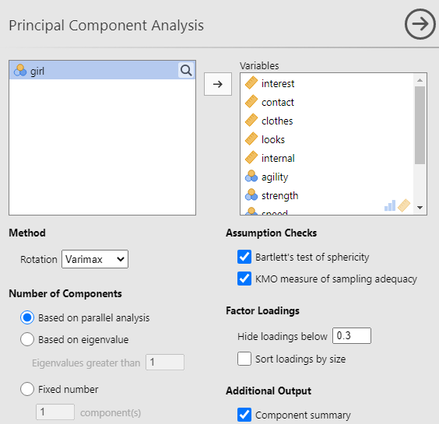

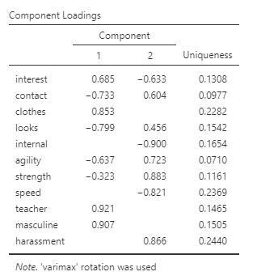

There are two components as seen on the component loadings table. Since both have more than 3 variables, it is valid to keep both components since they are more likely to be stable.
Summary
Component |  | SS Loadings |  | % of Variance |  | Cumulative %
1 |  | 4.67 |  | 42.5 |  | 42.5
2 |  | 4.59 |  | 41.7 |  | 84.2

Bartlett's Test of Sphericity
χ² |  | df |  | p
408 |  | 55 |  | < .001
The Bartlett’s test result is significant since the p value is less than 0.05. This means that we reject the null hypothesis that all the correlations tested simultaneously are ’not statistically different from zero’. This result is necessary to carry on with the interpretation of the analysis’ results.

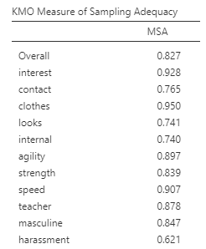

The measures of sampling adequacy for each variable should be at least .5, and the nearer to 1 the better. Here, we see that the overall statistic is over the minimum for all variables. Thus, we don’t need to remove any of them to continue.

Scree Plot
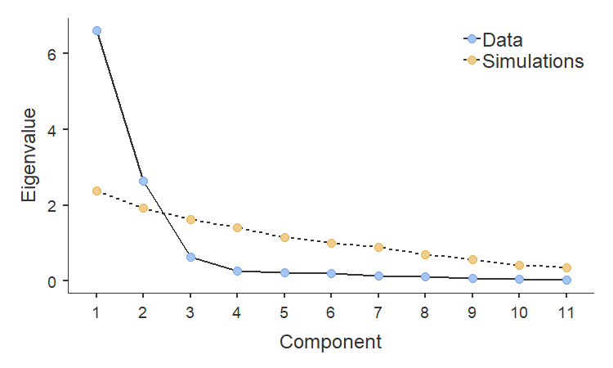
The scree plot supports the result of having two components. There are only two points above the scree (the rocks at the bottom of the hill). Also, the eigenvalues from the third component onwards are quite low.
EFA
Use the Job Burnout.csv file.
This is a survey of 99 teachers using the Maslach-Burnout Inventory General Survey (MBI-GS). The survey questions are as follows:
Question 1 I feel emotionally drained from my work.
Question 2 I feel used up at the end of the workday.
Question 3 I feel tired when I get up in the morning and have to face another day on the job.
Question 4 Working all day is really a strain for me.
Question 5 I can effectively solve the problems that arise in my work.
Question 6 I feel burned out from my work.
Question 7 I feel I am making an effective contribution to what this organization does.
Question 8 I have become less interested in my work since I started this job.
Question 9 I have become less enthusiastic about my work.
Question 10 In my opinion, I am good at my job.
Question 11 I feel exhilarated when I accomplish something at work.
Question 12 I have accomplished many worthwhile things in this job.
Question 13 I just want to do my job and not be bothered.
Question 14 I have become more cynical about whether my work contributes anything.
Question 15 I doubt the significance of my work.
Question 16 At my work, I feel confident that I am effective at getting things done.

The MBI-GS suggests that job burnout comprises of three major subscales namely exhaustion, cynicism, and professional efficacy. Based on this scale, questions 1,2,3,4 and 6 correspond to exhaustion, questions 8,9,13, 14, and 15 correspond to cynicism, and questions 5,7,10,11, and 12 correspond to professional efficacy
Conduct an exploratory factor analysis to see if the data will show the same three categories of underlying factors.

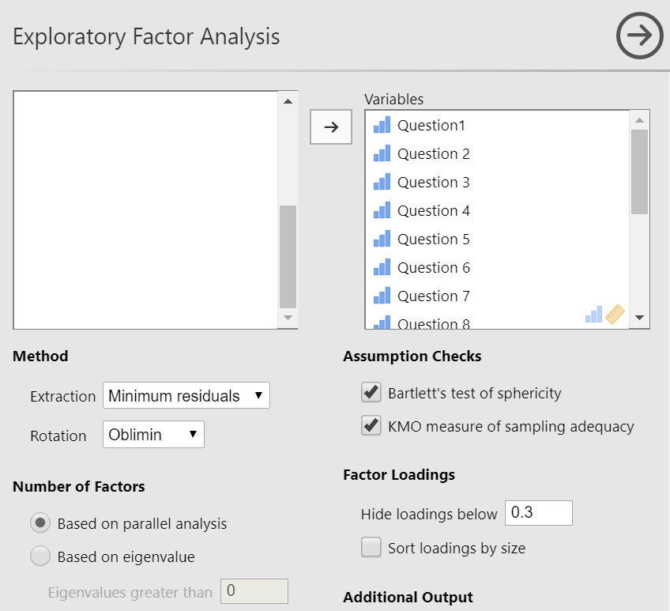
Bartlett's Test of Sphericity
χ² |  | df |  | p
809 |  | 120 |  | < .001
The Bartlett’s test result is significant since the p-value is less than 0.05. This means that we reject the null hypothesis that all the correlations tested simultaneously are ’not statistically different from zero’. This result is necessary to carry on with the interpretation of the analysis’ results.

KMO Measure of Sampling Adequacy
 |  | MSA
Overall |  | 0.810
Question1 |  | 0.830
Question 2 |  | 0.878
Question 3 |  | 0.885
Question 4 |  | 0.922
Question 5 |  | 0.783
Question 6 |  | 0.874
Question 7 |  | 0.737
Question 8 |  | 0.804
Question 9 |  | 0.792
Question 10 |  | 0.806
Question 11 |  | 0.731
Question 12 |  | 0.805
Question 13 |  | 0.561
Question 14 |  | 0.653
Question 15 |  | 0.725
Question 16 |  | 0.816
The measures of sampling adequacy for each variable should be at least .5, and the nearer to 1 the better. Here, we see that the overall statistic is over the minimum for all variables. So we don’t need to remove any of them to continue.

Scree Plot
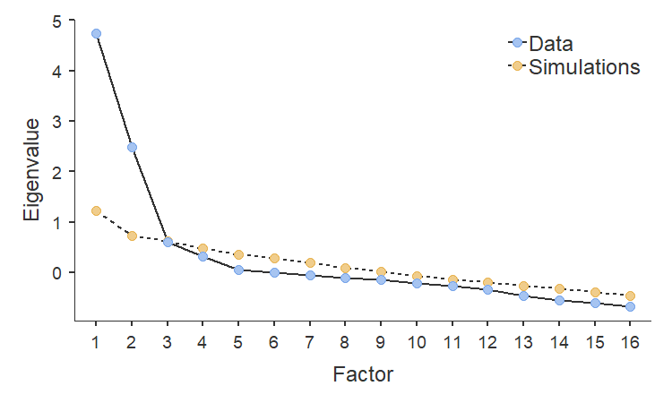
The scree plot suggests three factors. The factor loadings indicate similarly, using the default identification method (parallel analysis).
Factor Loadings
 |  | Factor
 |  | 1 |  | 2 |  | 3 |  | Uniqueness
Question1 |  | 0.769 |  |  |  |  |  | 0.433
Question 2 |  | 0.829 |  |  |  |  |  | 0.396
Question 3 |  | 0.811 |  |  |  |  |  | 0.313
Question 4 |  | 0.786 |  |  |  |  |  | 0.338
Question 5 |  |  |  | 0.624 |  |  |  | 0.620
Question 6 |  | 0.902 |  |  |  |  |  | 0.175
Question 7 |  |  |  | 0.732 |  |  |  | 0.466
Question 8 |  | 0.632 |  |  |  |  |  | 0.446
Question 9 |  | 0.625 |  |  |  |  |  | 0.472
Question 10 |  |  |  | 0.682 |  |  |  | 0.497
Question 11 |  |  |  | 0.431 |  |  |  | 0.774
Question 12 |  |  |  | 0.728 |  |  |  | 0.404
Question 13 |  |  |  |  |  | 0.497 |  | 0.664
Question 14 |  |  |  |  |  | 0.877 |  | 0.191
Question 15 |  |  |  |  |  | 0.307 |  | 0.771
Question 16 |  |  |  | 0.814 |  |  |  | 0.330
Note. 'Minimum residual' extraction method was used in combination with a 'oblimin' rotation
Although there is some discrepancy from the original grouping of questions, there is still a resemblance to the subscales as suggested by the MBI-GS.
Model Fit Measures
 |  | RMSEA 90% CI |  |  |  |  |  |  |  | Model Test
RMSEA |  | Lower |  | Upper |  | TLI |  | BIC |  | χ² |  | df |  | p
0.0889 |  | 0.0530 |  | 0.105 |  | 0.888 |  | -223 |  | 122 |  | 75 |  | < .001
To indicate a good fit, the RMSEA should be as small as possible and the TLI should be high. These were satisfied since RMSEA is only 0.089 and TLI is 0.88.

