Chapter 10
Repeated measures two-way ANOVA
Patients’ self-reports of their skin conditions were measured based on two sources suspected of being problematic, drinking a litre milk and sitting in a hot temperature controlled room. Both factors were measured pre- and post-occurrence. Each measurement used a scale of 1 to 10, 1 being the lowest level of irritation and 10 being the highest. One of the factors is the nature of the experimental condition; the other is time before and after the experiment.
Perform a repeated measures two-way ANOVA in JASP to analyze the individual and interaction effects of activity and time on the students’ anxiety levels (on the Repeated-measures two-way ANOVA csv file).
Pre_Milk | Post_Milk | Pre_Heat | Post_Heat
6 | 5 | 9 | 7
9 | 6 | 6 | 4
5 | 3 | 8 | 5
6 | 2 | 5 | 5
6 | 5 | 9 | 6
3 | 3 | 7 | 5
9 | 6 | 7 | 5
4 | 2 | 4 | 3
8 | 5 | 6 | 5
7 | 2 | 8 | 4

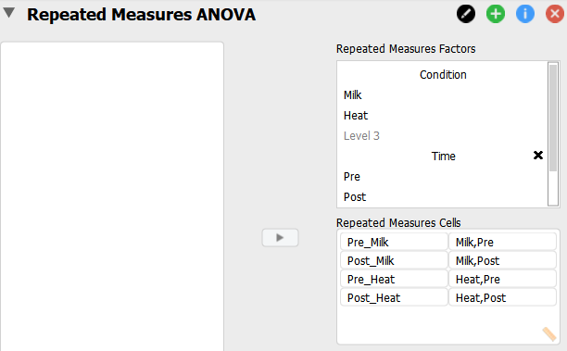

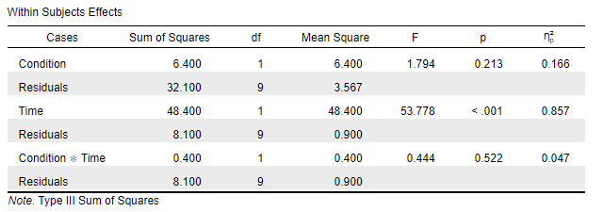
The results show that only time has a significant effect since its p value is less than 0.05. In addition, it has a very large effect size (use 'Estimates of effect size' to find this). The interaction effect and the Condition effect are insignificant.
Between-Subjects ANOVA
Composite scales are completed by patients with depression at the end of a period of therapy. Each patient has been treated with one of four different therapies, and the therapist was also noted. The results are as follows (in the Between Subjects ANOVA csv file):
Scale | Therapy | Therapist
109 | 1 | 1
110 | 1 | 1
110 | 1 | 2
112 | 1 | 2
116 | 1 | 3
114 | 1 | 3
110 | 2 | 1
115 | 2 | 1
110 | 2 | 2
111 | 2 | 2
112 | 2 | 3
115 | 2 | 3
108 | 3 | 1
109 | 3 | 1
111 | 3 | 2
109 | 3 | 2
114 | 3 | 3
119 | 3 | 3
110 | 4 | 1
108 | 4 | 1
114 | 4 | 2
112 | 4 | 2
120 | 4 | 3
117 | 4 | 3

Test to see if there is a difference in scale results according to the factors considered.
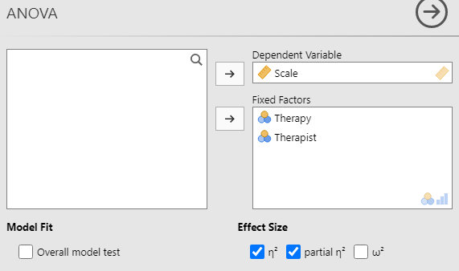
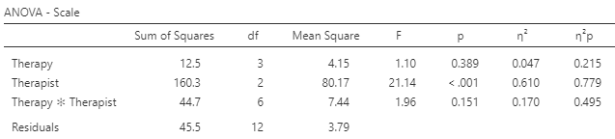
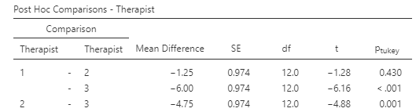

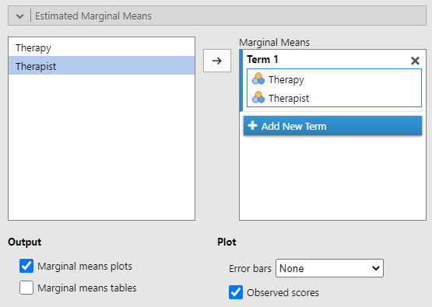

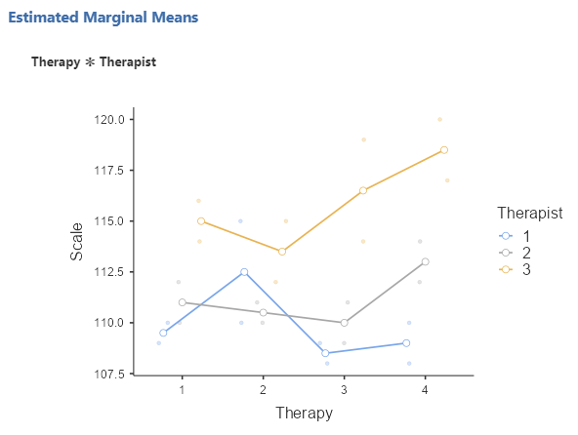

The ANOVA results show that the scale results differ based upon the therapist (the p value is lower than 0.05). Moreover, this has a very large effect size at 0.779. Since there are three therapists, a post hoc test may be useful: therapists 1 and 3 as well as 2 and 3 have significantly different effects on the results scale. As shown in the plot, therapist 3 appears to elicit the highest scale result whichever therapy was used.

Mixed ANOVA
In this (completely imaginary) study of people recovering from physical injuries, we want to see differences in clinical reports, dependent on the stage of therapy (Injury 1 is at the beginning; Injury 2 is at an intermediate stage; Injury 3 is towards the end of treatment), and the type of (alternating) treatment. Below are the results (also on the Mixed ANOVA.csv file):
Patient | Injury | Pain Relief | Immobilisation
1 | 1 | 23 | 24
2 | 1 | 24 | 23
3 | 1 | 25 | 28
4 | 2 | 30 | 38
5 | 2 | 28 | 36
6 | 2 | 26 | 35
7 | 3 | 31 | 34
8 | 3 | 32 | 36
9 | 3 | 29 | 39

Conduct a mixed ANOVA with JASP and identify which factors are associated with clinical outcomes.

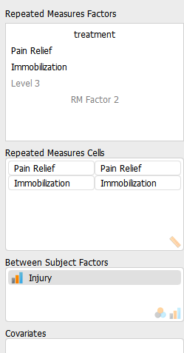
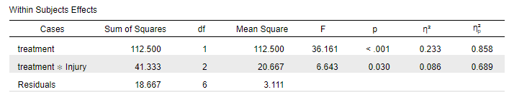

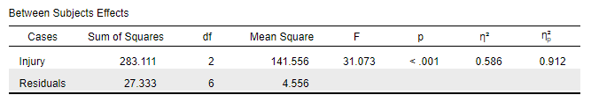

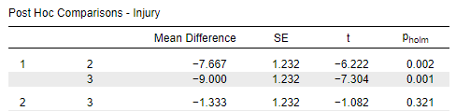

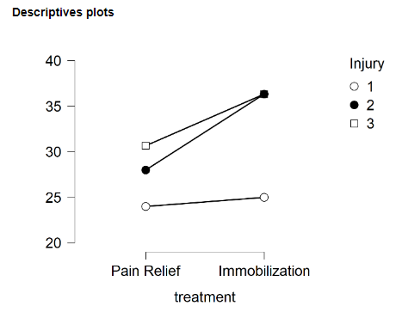
The within subject and between subject effects are both significant, as is their interaction. Moreover, they have large effect sizes (partial eta squared has been used). The post hoc tests indicate differences between injury stages 1 and 2, and between stages 1 and 3.
The descriptives plot shows that on both types medical intervention, injury stage 1 produces the lowest average score. Injury stage 3 has a higher average score than injury stage 2 under pain relief but there was no clear difference between using mobilization.

