Chapter 15 Partial and Semi Partial Correlations
Open Academic Pay.csv in Jamovi and examine the correlation matrix for salary, yrs.service and rank.

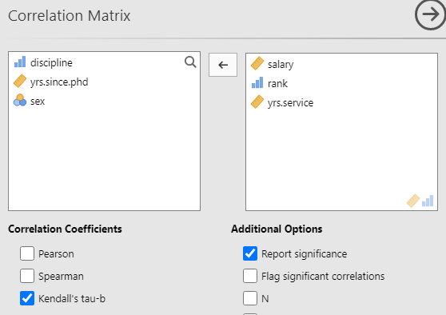

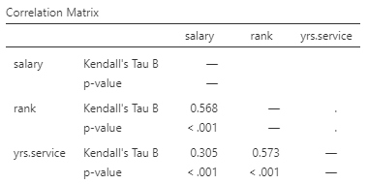

Clearly, both years of service and rank are related to salary, but is there a relationship that has been missed? A plausible 'real world' explanation is that rank is the real driver of salary and that years of service are probably less directly related to salary. Examine this triangle using partial correlations.

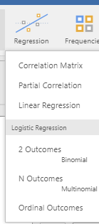
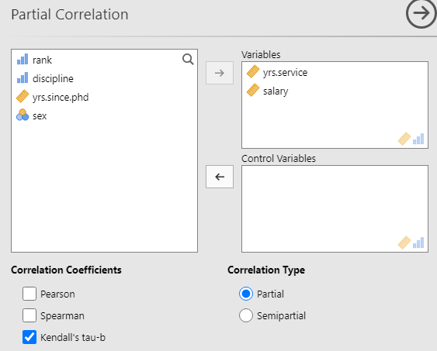

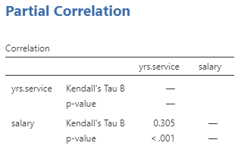
As in the correlation matrix, years of service seems at first glance to be directly related to salary.
We now add rank as a control variable.
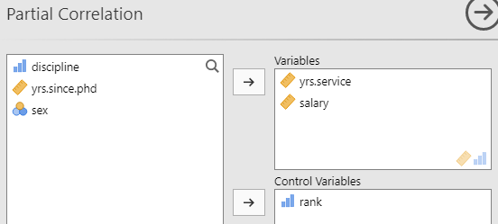

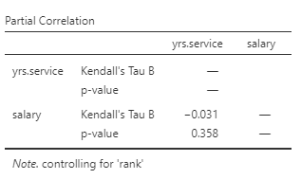
We can see from the results that the relationship between years in service and salary appears to be insignificant, when controlled by 'rank', since its p value is greater than 0.05.

