Factorial ANOVA
Repeated measures two-way ANOVA
Students’ levels of anxiety were measured based on two sources, examinations and social interaction. Both factors were measured pre- and post-activity. Each measurement used a scale of 1 to 10, 1 being the lowest and 10 being the highest. One of the factors is the source of anxiety; the other is time before and after the activity.
Perform a repeated measures two-way ANOVA to analyze the individual and interaction effects of activity and time on the students’ anxiety levels (on the Repeated-measures two-way ANOVA csv file).
PreExam_Anxiety | PostExam_Anxiety | PreSocial_Anxiety | PostSocial_Anxiety
6 | 5 | 9 | 7
9 | 6 | 6 | 4
5 | 3 | 8 | 5
6 | 2 | 5 | 5
6 | 5 | 9 | 6
3 | 3 | 7 | 5
9 | 6 | 7 | 5
4 | 2 | 4 | 3
8 | 5 | 6 | 5
7 | 2 | 8 | 4

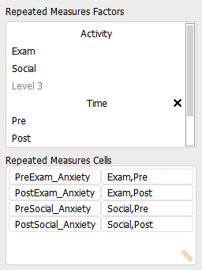

Within Subjects Effects
 |  | Sum of Squares |  | df |  | Mean Square |  | F |  | p |  | η² _{p}
Activity |  | 6.400 |  | 1 |  | 6.400 |  | 1.794 |  | 0.213 |  | 0.166
Residual |  | 32.100 |  | 9 |  | 3.567
Time |  | 48.400 |  | 1 |  | 48.400 |  | 53.778 |  | < .001 |  | 0.857
Residual |  | 8.100 |  | 9 |  | 0.900
Activity ✻ Time |  | 0.400 |  | 1 |  | 0.400 |  | 0.444 |  | 0.522 |  | 0.047
Residual |  | 8.100 |  | 9 |  | 0.900
Note. Type III Sum of Squares

The results show that only time has a significant effect since its p value is less than 0.05. In addition, it has a very large effect size (use 'Additional Options' to find this). The interaction effect and the Activity effect are insignificant.
Between-Subjects ANOVA
During a period of lockdown for COVID-19, wellbeing is broken down according to social class and environs. Class: 1 = poor, 2 = working class, 3 = middle class, 4 = upper middle/upper class.
Environs: 1 = urban, 2 = suburban, 3 = rural
The results are as follows (in the Between Subjects ANOVA csv file):
Wellbeing | Class | Environs
109 | 1 | 1
110 | 1 | 1
110 | 1 | 2
112 | 1 | 2
116 | 1 | 3
114 | 1 | 3
110 | 2 | 1
115 | 2 | 1
110 | 2 | 2
111 | 2 | 2
112 | 2 | 3
115 | 2 | 3
108 | 3 | 1
109 | 3 | 1
111 | 3 | 2
109 | 3 | 2
114 | 3 | 3
119 | 3 | 3
110 | 4 | 1
108 | 4 | 1
114 | 4 | 2
112 | 4 | 2
120 | 4 | 3
117 | 4 | 3

Test to see if there is a difference in the wellbeing scores according to the factors considered.
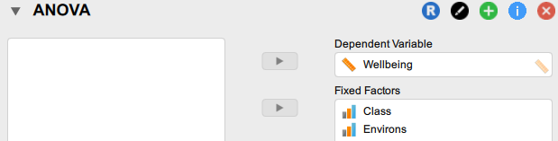

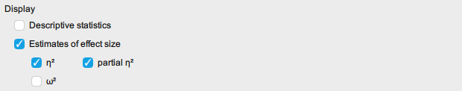

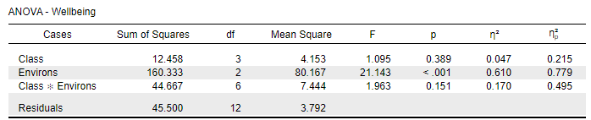
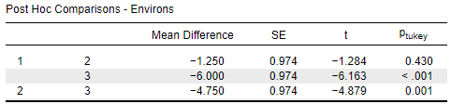

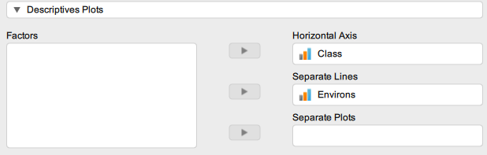

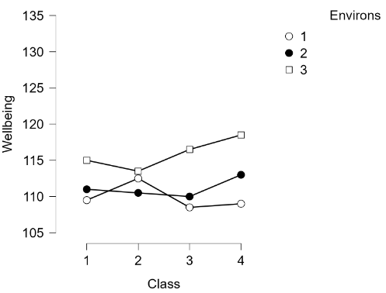

The ANOVA results show that the Wellbeing score differs based upon the environs (the p value is lower than 0.05). Moreover, this has a very large effect size at 0.779. Since there are three categories of environ, a post hoc test may be useful: environs 1 and 3 (urban and rural) as well as 2 and 3 (suburban and rural) have significantly different effects on the scale. As shown in the plot, environment 3 (rural) appears to elicit the highest Wellbeing score of all of the environs.

Mixed ANOVA
In this (completely imaginary) study, dementia patients in their 80s are given half hour talking sessions, later followed by a memory test. All participants have discussions both with an artificial intelligence 'friend' and, at another time, with a member of staff. While the content matter is the same, the context differs for each group of patients: time context 1 is set within the individuals' youth; time context 2 is set in middle age; the setting for context 3 is when the individuals were in their 70s.
Patient | Time context | RoboFriend | Human
1 | 3 | 23 | 24
2 | 3 | 24 | 23
3 | 3 | 25 | 28
4 | 2 | 30 | 38
5 | 2 | 28 | 36
6 | 2 | 26 | 35
7 | 1 | 31 | 34
8 | 1 | 32 | 36
9 | 1 | 29 | 39

Conduct a mixed ANOVA and identify which factors are associated with clinical outcomes.
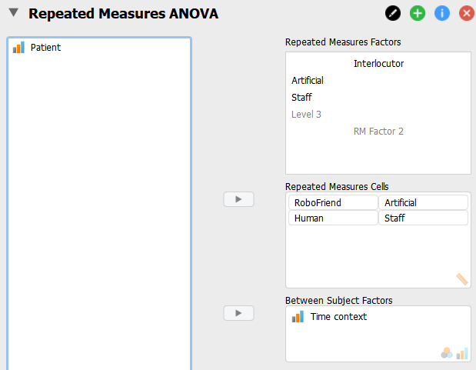
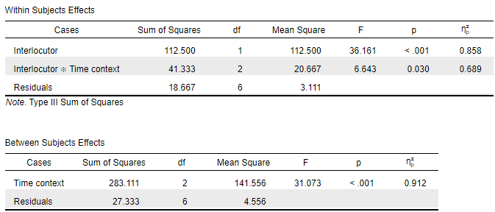

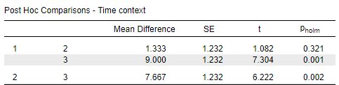

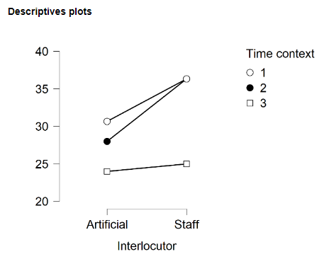
The within subject and between subject effects are both significant, as is their interaction. Moreover, they have large effect sizes (partial eta squared has been used). The post hoc tests indicate differences between contexts 1 and 3, and between contexts 1 and 3 (memories based on the 'old age' context seem to differ from the earlier ones).
The descriptives plot shows that on both types of exercise machine, context 3 produces the lowest average score. Context 1 has a higher average score than context 2 relating to the AI friend, but there was no clear difference between them speaking with a human.

