Null hypothesis significance testing
Given the data set of self-reports of height and weight (use the Height and Weight Data.csv file), use the independent samples t-test to assess the null hypothesis that the mean weight of male respondents is equal to the mean weight of female respondents.
H0: $Mean weight of males= Mean weight of females$
If you have not yet learned to use this test (in the Analysis of Differences chapter):
Use the T-Tests tab, then Classical / Independent Samples T-Test.

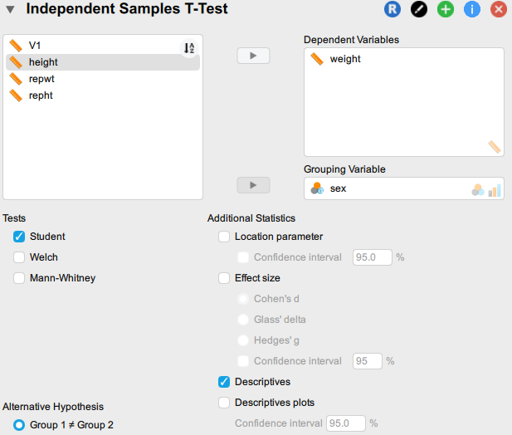

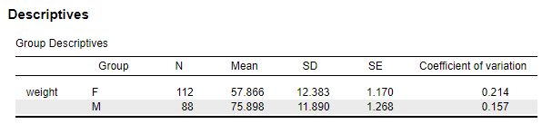
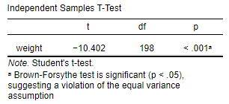

The group descriptives show that the mean weight of males is considerably higher than the mean weight of females. Since the significance value (p < .001) is less than the critical value 0.05, we have evidence to reject the null hypothesis that males and females have equal mean weight.
(As you will notice, JASP does indicate a violation of assumptions. You will learn more about this in Chapter 6, Tests of differences. Suffice it to say that alternative tests will show a very similar result in this case.)

