Application of Bayesian Statistics
Open the Student Grades.csv file in JASP. This contains before and after intervention test scores for the same group of students. Conduct a paired sample t test to assess if there is a significant difference in the mean scores before and after intervention. Run the Bayesian equivalent of the paired sample t test and interpret the results.
If you have not used this test yet, the paired sample t test is run by pressing the T-Tests tab, and from the drop-down menu, select Classical / Paired Samples T-Test.
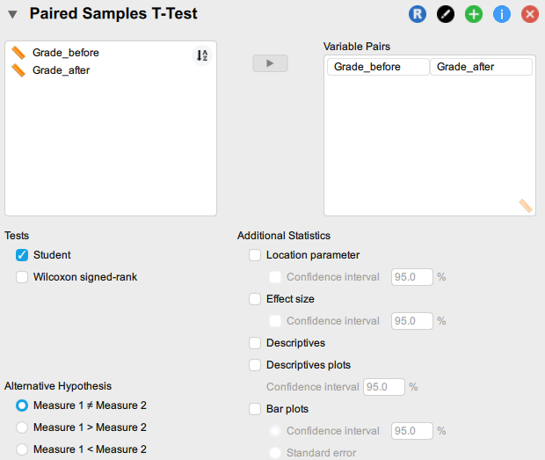
And this is how to run the Bayesian t test – press the T-Tests tab, then selecting from the drop-down, Bayesian / Paired Samples T-Test.
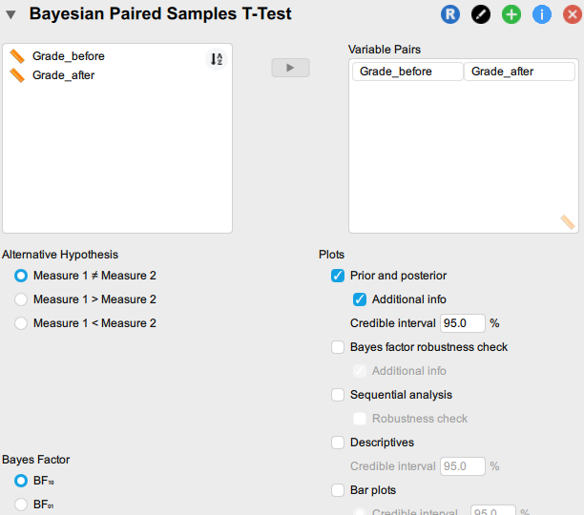

What are the null and alternative hypotheses?
H0 (null hypothesis): There is no significant difference between the average students’ scores before and after intervention class.
H1 (alternative hypothesis): There is a significant difference between the average students’ scores before and after intervention class.

Examine the frequentist and Bayesian results:

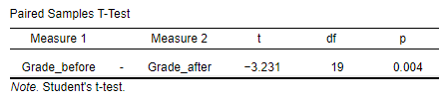
We have evidence to reject the null hypothesis, with p as smaller than .05 (p < .05).
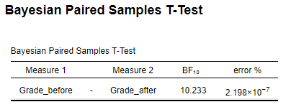
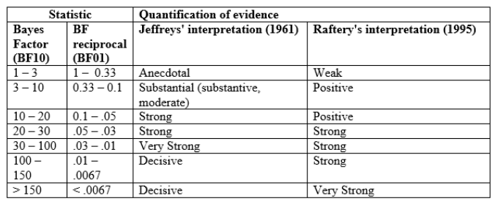
Jeffreys (1961) considers a Bayes factor between 10 and 30, as is the case in this analysis, as representing strong evidence towards the alternative hypothesis. Raftery (1995) considers a Bayes factor of between 3 and 20 as Positive. In either case, the Bayes factor indicates evidence in favour of the alternative hypothesis.

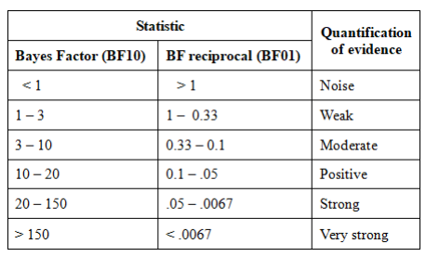
This is my own take on interpreting Bayes factors (basically, a meld of Jeffreys and Raftery, with a little interpretive ingredient of E-J Wagenmakers). A Bayes factor of just over 10 reaches the ‘Positive’ category, just. One would be hard-pushed to consider the credibility as ‘Strong’, although it does attain this in Jeffreys’ interpretation.
As noted in the book, there is an element of subjectivity, in particular when deciding which reporting system. What I would recommend is that the system is decided upon before tests are run; if not, you may be accused of engineering the interpretation of your results.
To offer an alternative to my take, here is a Jeffreys-based model of interpretation by Dr Jon Starkweather.
A Bayes factor of 1.00 represents equal odds for either model (the null and alternative hypotheses), a Bayes factor greater than 1.00 represents evidence for the one model (e.g. the null hypothesis), and a Bayes factor less than 1.00 represents evidence for another model (e.g. the alternative hypothesis).
The interpretation of magnitude for a Bayes factor, like traditional effect size estimates, involves some flexible categories (suggested by Jeffreys, 1961). For instance, a Bayes factor between (roughly) 1.00 and 3.00 (or between 1 and 0.30) represents scarce evidence, a Bayes factor between (roughly) 3.00 and 10.00 (or between 0.30 and 0.10) represents substantial evidence, a Bayes factor between (roughly) 10.00 and 30.00 (or between 0.10 and 0.03) represents strong evidence, and a Bayes factor between (roughly) 30.00 and 100.00 (or between 0.03 and 0.01) represents very strong evidence (Jeffreys).
It is important to note; theoretically, there is no limit to the magnitude of a Bayes factor, Jeffreys suggested that a Bayes factor greater than 100.00 (or less than 0.01) would represent decisive evidence. So, the benefits of taking a Bayesian perspective (beyond the general reasons for choosing a Bayesian perspective over a frequentist perspective) are that in these simple situations, a Bayes factor is one number which is easily interpreted for both identifying an effect and measuring the magnitude of the effect. By contrast, the frequentist p value is easily confused, controversial, and would involve another statistic to express the magnitude of effect (i.e. effect size; e.g. Cohen’s d).

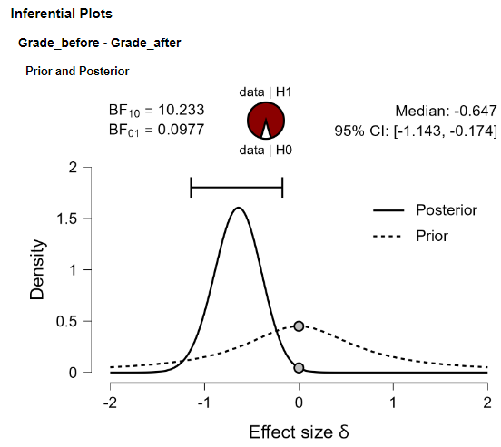
The difference between the Posterior and Prior makes the credibility of the effect very clear.

