Tests of Differences

Exercise 1
The data below shows students’ scores before and after a discussion about the benefits of education. Assume here that we are expecting an improvement afterwards.
- Explain what type of analysis is appropriate for this data set to determine whether or not there is a significant difference between the students’ scores before and after the intervention class. Do we use a one-tailed or two-tailed hypothesis?
A related sample design such as paired samples t-test is necessary to test the hypothesis since the grades to be compared were taken from the same students. As we have reason to expect a result in one direction, then a one-tailed hypothesis is appropriate.
- Open the Student Grades.csv file in JASP.
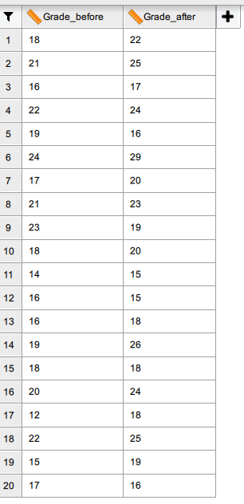
- Perform the appropriate analysis and interpret the results according to the formed hypothesis.
Use T-Tests / Classical / Paired Samples T-Test. For our one-tailed hypothesis, use the 'Measure 1 < Measure 2' hypothesis option. The Descriptives option and Descriptives plots would also be useful.
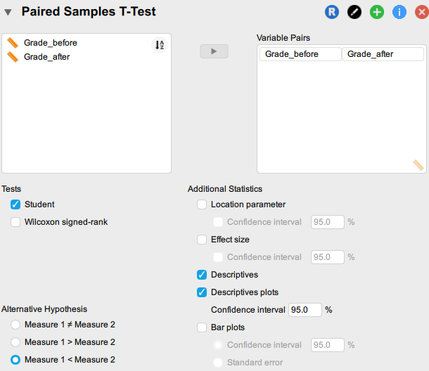
The results should look as follows:
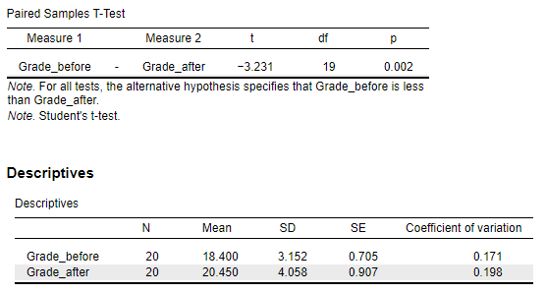

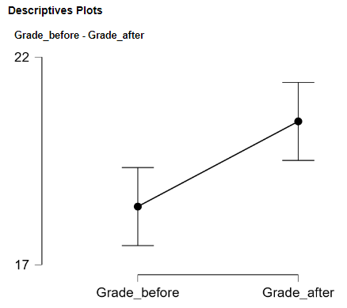
The plot shows that the grades after the intervention class tend to be higher than the grades before it. Looking at the p value, the paired samples T-Test results show that there is a significant difference between the students’ grades before and after the intervention class (p < .05) with a mean difference of approximately 2.

Exercise 2
A study assessed the effectiveness of a feedback technique used by police to reduce antisocial street behavior without arrests. A total of 8 policing areas are engaged in the study and the number of incidents of illicit or aggressive behavior are measured both for a month before the introduction of the feedback method and then again for a month afterwards. The data are shown below (you will also find this in the Feedback Technique.csv file).
Area | Before Technique | One Week of Technique
1 | 85 | 75
2 | 70 | 50
3 | 40 | 50
4 | 65 | 40
5 | 80 | 20
6 | 75 | 65
7 | 55 | 40
8 | 20 | 25

- Given this small dataset, explain what is the appropriate test to see if there is a significant difference between the median of two groups.
Wilcoxon signed rank test, which is a non-parametric counterpart of paired samples t-test, is appropriate to use in this study.
- State the null and alternative hypotheses.
H0: The average repetitive behavior scores before and after treatment are the same.
H1: The average repetitive behavior scores before and after treatment are not the same.
- Open the Feedback Technique.csv in JASP.
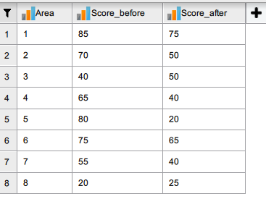

- Perform the appropriate analysis and interpret the results according to the formed hypothesis.
Use T-Tests / Classical / Paired Samples T-Test, but selecting the Wilcoxon signed rank option. Choose the two-tailed hypothesis, Measure One does not equal Measure Two, as we don’t really know whether or not the new technique will be an improvement.
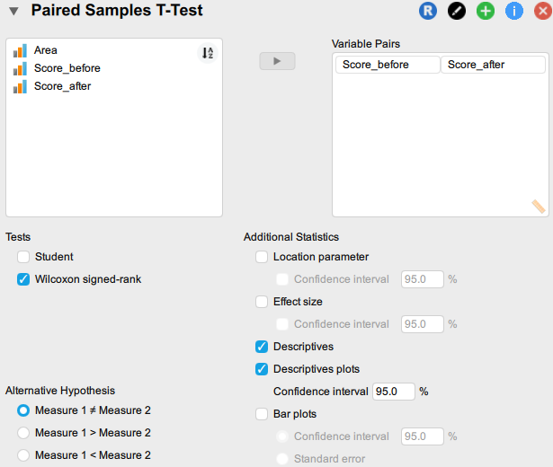
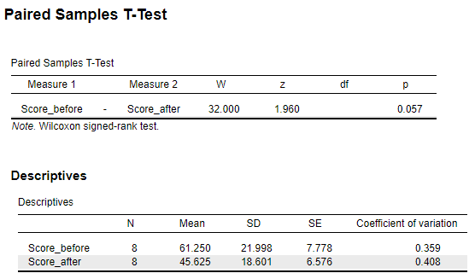

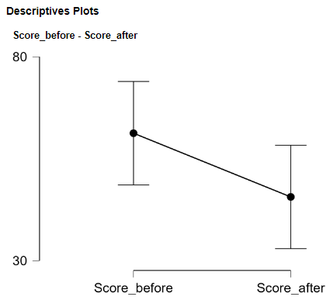

The plot shows that the average score before the intervention is higher than the score after treatment, with a mean difference of 12.8. If we applied a 0.05 critical value, the Wilcoxon signed rank test results would not allow us to reject the null hypothesis that the scores are similar before and after the treatment. However, given the small number of cases, some would consider applying a critical value of 0.10, so p < .10; however, most would suggest using larger samples!
Exercise 3
The group from Exercise One have had a further intervention:

Student | Before Intervention | After First Intervention Class | After Second Intervention Class
1 | 18 | 22 | 20
2 | 21 | 25 | 22
3 | 16 | 17 | 20
4 | 22 | 24 | 26
5 | 19 | 16 | 15
6 | 24 | 29 | 30
7 | 17 | 20 | 25
8 | 21 | 23 | 26
9 | 23 | 19 | 25
10 | 18 | 20 | 23
11 | 14 | 15 | 20
12 | 16 | 15 | 14
13 | 16 | 18 | 22
14 | 19 | 26 | 24
15 | 18 | 18 | 19
16 | 20 | 24 | 23
17 | 12 | 18 | 25
18 | 22 | 25 | 27
19 | 15 | 19 | 22
20 | 17 | 16 | 20

- Explain why administering multiple t-tests would not be beneficial for this scenario. Which test is appropriate?
Every time you conduct a t-test, there is a chance of rejecting a true null hypothesis (a 'type 1 error'). Thus, conducting multiple paired sample t-tests in this case will increase the error rate.
To avoid this, the one-way repeated measures ANOVA is appropriate.

- State the null and alternative hypotheses.
H0: There is no significant difference between the average score among the three data sets.
H1: There is a significant difference between the average scores among the three data sets.
- Load Student Grades Extended.csv into JASP.

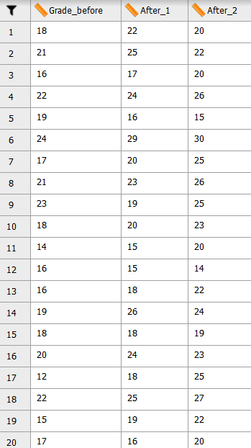

- Perform the appropriate analysis and interpret the results related to the hypothesis. Perform the procedure for setting up Repeated Measures ANOVA in JASP as shown in the book. The dialog box should end up looking something like this:

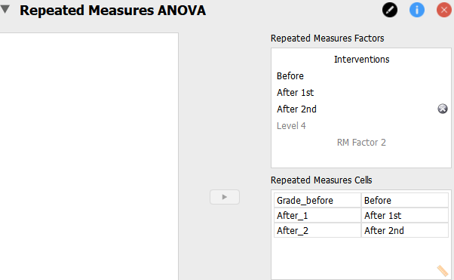

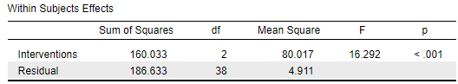

Assuming that the critical value has been predetermined as 0.05, p < .05; we may reject the null hypothesis that there is no significant difference on the average grades among the three groups.

To identify any significant pairings, use the Holm post hoc test. Also, show a descriptive plot to visualize the mean grade per group and easily identify their differences.

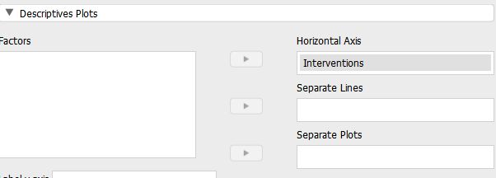

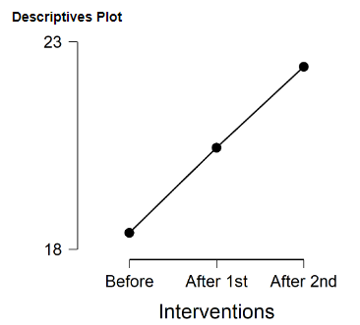

All pairings appear to be significantly different.

Exercise 4
Let us consider whether or not contact with foreigners in general will have an effect on attitudes to refugees specifically. One set of participants in a study live in an area with a high proportion of foreign tourists; the other set does not encounter foreigners so much. Do note that each separate group needs to be represented by a number (here, within the 'Group' variable); this would be the same with an ANOVA (independent samples / unrelated), only with more than 2 such numbers.
This data set is available in Refugee Study.csv
Participant | Score | Group
1 | 18 | 1
2 | 21 | 1
3 | 16 | 1
4 | 22 | 1
5 | 19 | 1
6 | 24 | 1
7 | 17 | 1
8 | 21 | 1
9 | 23 | 1
10 | 18 | 1
11 | 14 | 1
12 | 16 | 1
13 | 16 | 1
14 | 19 | 1
15 | 18 | 1
16 | 20 | 1
17 | 12 | 1
18 | 22 | 1
19 | 15 | 1
20 | 17 | 1
21 | 22 | 2
22 | 25 | 2
23 | 17 | 2
24 | 24 | 2
25 | 16 | 2
26 | 29 | 2
27 | 20 | 2
28 | 23 | 2
29 | 19 | 2
30 | 20 | 2
31 | 15 | 2
32 | 15 | 2
33 | 18 | 2
34 | 26 | 2
35 | 18 | 2
36 | 24 | 2
37 | 18 | 2
38 | 25 | 2
39 | 19 | 2
40 | 16 | 2

- State the null and alternative hypotheses.
H0: There is no significant difference between the average scores of participants in the two groups.
H1: There is a significant difference between the average scores of participants in the two groups.

- Which test is appropriate here?
The Independent samples t test. There are only two groups. The scores being compared are from different participants (who did not recall under both conditions). An examination of the dependent variable (Score) will show that the data can be considered normal; otherwise, a Mann-Whitney test would be preferred.

- Open Refugee Study.csv in JASP.

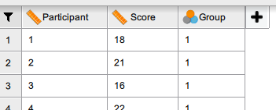
- Perform the analysis and interpret the results.
Use T-Tests / Classical / Independent Samples T-Test procedure, as shown in the book. First, check normality assumptions; the Descriptives tab is recommended for normality. Within the Independent Samples T-test dialog, also select Equality of variances.
In this case, all assumptions were satisfied.
Note that the null hypotheses for the normality test and equality of variances test are as follows:
H0: The data follows the assumption of normality
H0: The data follows the assumption of equality of variances

Thus, having p values greater than 0.05, these null hypotheses are not rejected.

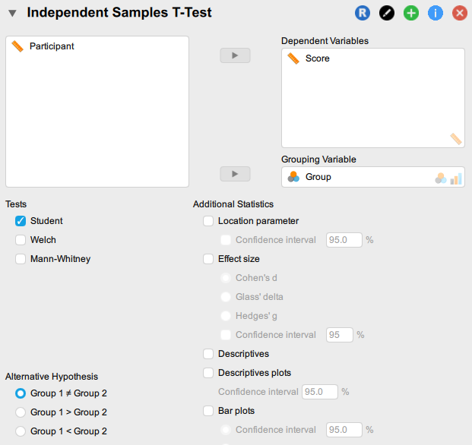
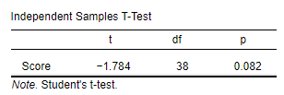
Since the p value is greater than 0.05, we do not reject the null hypothesis. There is no significant difference between the average scores of participants under the two conditions.

