Categorical analyses
Using the Salaries.csv data set in JASP, examine the different ranks of academics to see if the proportions are to be expected. To give you some idea of what is going on, you may find it useful to start by studying the descriptive statistics (which is usual good practice) for the 'rank' variable.
What is the most appropriate test?
Well, let’s look at Descriptive Statistics first (from the Descriptives tab).
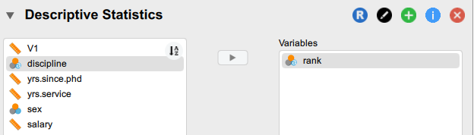
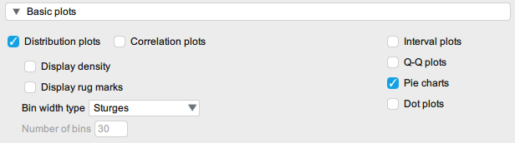
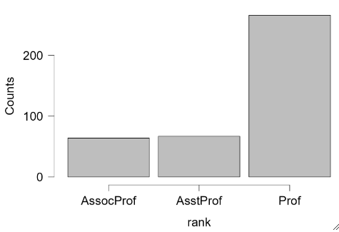
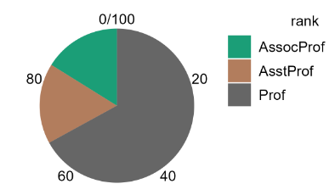

We see three categories within one variable. The multinomial test (also known as Chi Squared Goodness of Fit) is appropriate, as it analyzes the frequencies of more than two categories within a single variable. To find this, got to the Frequencies tab and select Classical / Multinomial test.
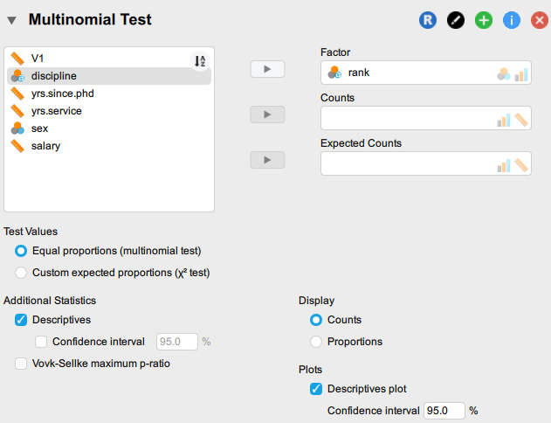
What are the null and alternative hypotheses?
H0: There is no significant difference from the expected proportion.
H1: There is a significant difference from the expected proportion.
Interpret the results. For simplicity's sake, use the default ‘Equal proportions’ as expected proportions.
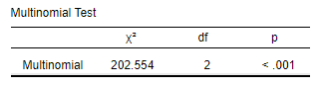
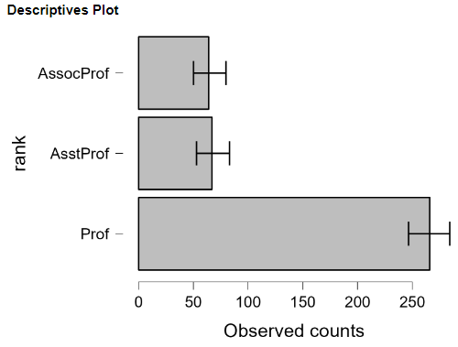

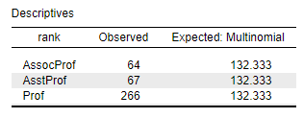
The Descriptives chart shows the observed and expected counts for each professorial rank. Since we are testing for equal proportions, the expected count is 132 for each level. However, it can be seen that the Prof level has a higher observed than expected count while both AsstProf and AssocProf level have low observed scores compared to the expected counts.
We have a large Chi squared statistic and a low p value which is less than 0.001. Thus, we reject the null hypothesis that there is no significant difference between the expected proportions.

