Application of Bayesian Statistics
Open the Student Grades.csv file in JASP. This contains before and after intervention test scores for the same group of students. Conduct a paired sample t test to assess if there is a significant difference in the mean scores before and after intervention. Run the Bayesian equivalent of the paired sample t test and interpret the results.
If you have not used this test yet, the paired sample t test is run by pressing the T-Tests tab, and from the drop-down menu, select Classical / Paired Samples T-Test.
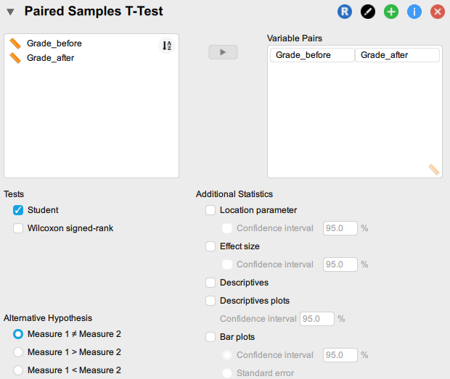

And this is how to run the Bayesian t test – press the T-Tests tab, then selecting from the drop-down, Bayesian / Paired Samples T-Test.

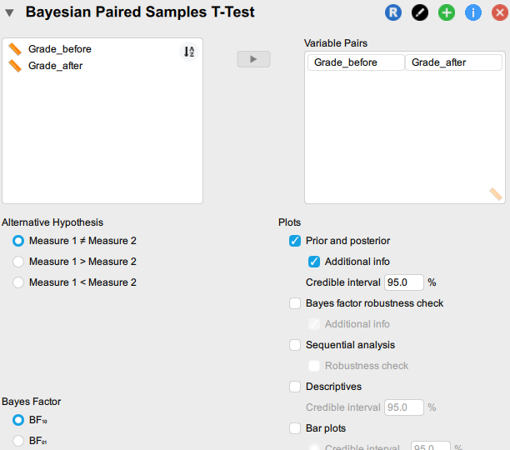

What are the null and alternative hypotheses?

Examine the frequentist and Bayesian results:

