Chapter 15 Partial and Semi Partial Correlations
Open the Academic Pay.csv data in JASP and perform a regression model examining if years in service explains the salary differentials among professors. Next, analyze if rank has a partial correlation effect on the association of these two variables.
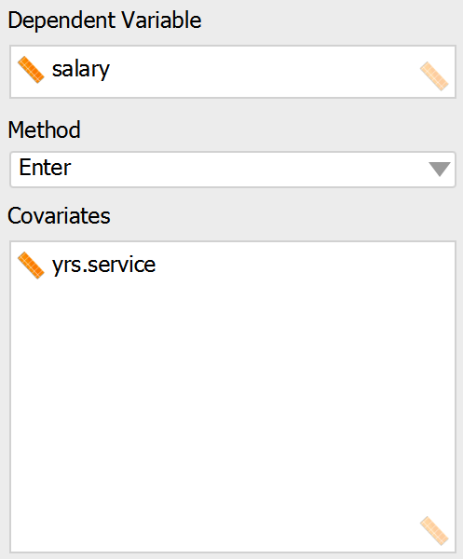

Linear Regression
Model Summary
Model |  | R |  | R² |  | Adjusted R² |  | RMSE
1 |  | 0.335 |  | 0.112 |  | 0.110 |  | 28577.736
ANOVA
Model |  |  |  |  | Sum of Squares |  |  |  | df |  | Mean Square |  | F |  | p
1 |  | Regression |  |  | 4.071e +10 |  |  |  | 1 |  | 4.071e +10 |  | 49.847 |  | < .001
 |  | Residual |  |  | 3.226e +11 |  |  |  | 395 |  | 8.167e +8
 |  | Total |  |  | 3.633e +11 |  |  |  | 396

Coefficients
Model |  |  |  | Unstandardized |  | Standard Error |  | Standardized |  | t |  | p
1 |  | (Intercept) |  | 99974.653 |  | 2416.605 |  |  |  | 41.370 |  | < .001
 |  | yrs.service |  | 779.569 |  | 110.417 |  | 0.335 |  | 7.060 |  | < .001

The regression results show that years in service is a significant predictor of a professor’s salary since the p value of the coefficient is less than 0.05. This is intuitive since years in service are an indicator of tenure.
Add Rank as a variable and look at its partial correlation with the two variables to see if it is necessary to make it a control variable because it affects the association of salary and years in service.

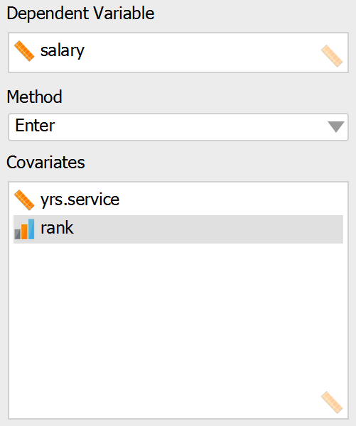
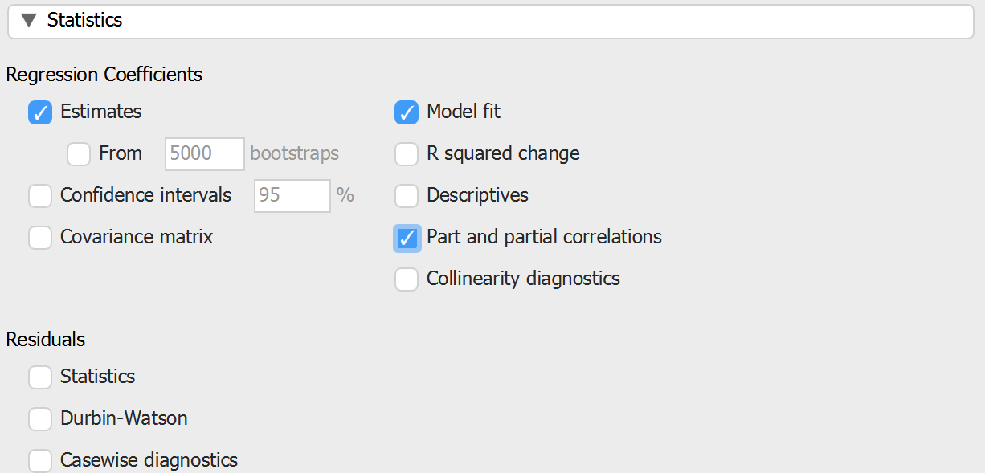

Linear Regression
Model Summary
Model |  | R |  | R² |  | Adjusted R² |  | RMSE
1 |  | 0.619 |  | 0.384 |  | 0.380 |  | 23840.520
ANOVA
Model |  |  |  |  | Sum of Squares |  |  |  | df |  | Mean Square |  | F |  | p
1 |  | Regression |  |  | 1.394e +11 |  |  |  | 2 |  | 6.968e +10 |  | 122.598 |  | < .001
 |  | Residual |  |  | 2.239e +11 |  |  |  | 394 |  | 5.684e +8
 |  | Total |  |  | 3.633e +11 |  |  |  | 396

Coefficients
Model |  |  |  | Unstandardized |  |  |  | Standard Error |  | Standardized |  | t |  | p
1 |  | (Intercept) |  | 51546.264 |  |  |  | 4192.410 |  |  |  | 12.295 |  | < .001
 |  | yrs.service |  | -150.647 |  |  |  | 116.061 |  | -0.065 |  | -1.298 |  | 0.195
 |  | rank |  | 25912.460 |  |  |  | 1966.837 |  | 0.657 |  | 13.175 |  | < .001
Part And Partial Correlations
Model |  |  |  |  | Partial |  | Part
1 |  | yrs.service |  |  | -0.065 |  | -0.051
 |  | rank |  |  | 0.553 |  | 0.521

We can see from the results that years in service appears insignificant since its p value is greater than 0.05. Moreover, the partial correlation of rank is high further indicating that it should be controlled when looking at the relationship of years in service and salary.
Take note that the method of JASP in looking at partial correlation is within a regression model, not just purely correlation which other tools execute. Some doubt should therefore be cast on using this particular part of the JASP toolkit.

