Chapter 10
Repeated measures two-way ANOVA
Students’ levels of anxiety were measured based on two sources, examinations and bungee jumping. Both factors were measured pre- and post-activity. Each measurement used a scale of 1 to 10, 1 being the lowest and 10 being the highest. One of the factors is the source of anxiety; the other is time before and after the activity.
Perform a repeated measures two-way ANOVA in JASP to analyze the individual and interaction effects of activity and time on the students’ anxiety levels (on the Repeated-measures two-way ANOVA csv file).
PreExam_Anxiety | PostExam_Anxiety | PreBungee_Anxiety | PostBungee_Anxiety
6 | 5 | 9 | 7
9 | 6 | 6 | 4
5 | 3 | 8 | 5
6 | 2 | 5 | 5
6 | 5 | 9 | 6
3 | 3 | 7 | 5
9 | 6 | 7 | 5
4 | 2 | 4 | 3
8 | 5 | 6 | 5
7 | 2 | 8 | 4

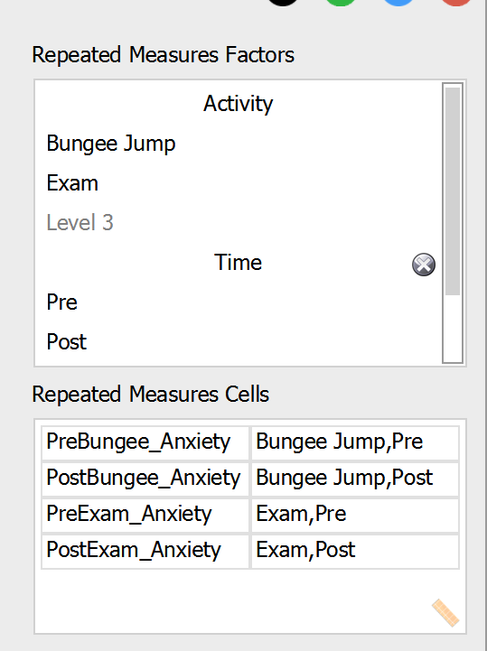

Within Subjects Effects
 |  | Sum of Squares |  | df |  | Mean Square |  | F |  | p |  | η² _{p}
Activity |  | 6.400 |  | 1 |  | 6.400 |  | 1.794 |  | 0.213 |  | 0.166
Residual |  | 32.100 |  | 9 |  | 3.567
Time |  | 48.400 |  | 1 |  | 48.400 |  | 53.778 |  | < .001 |  | 0.857
Residual |  | 8.100 |  | 9 |  | 0.900
Activity ✻ Time |  | 0.400 |  | 1 |  | 0.400 |  | 0.444 |  | 0.522 |  | 0.047
Residual |  | 8.100 |  | 9 |  | 0.900
Note. Type III Sum of Squares

The results show that only time has a significant effect since its p value is less than 0.05. In addition, it has a very large effect size (use 'Additional Options' to find this). The interaction effect and the Activity effect are insignificant.
Between-Subjects ANOVA
Rowing exercises are being used for rehabilitation purposes. Each patient has rowed for a 5 minute period. Four different rowing machines are chosen, and the trainer was also noted. The results are as follows (in the Between Subjects ANOVA csv file):
Strokes | Machine | Trainer
109 | 1 | 1
110 | 1 | 1
110 | 1 | 2
112 | 1 | 2
116 | 1 | 3
114 | 1 | 3
110 | 2 | 1
115 | 2 | 1
110 | 2 | 2
111 | 2 | 2
112 | 2 | 3
115 | 2 | 3
108 | 3 | 1
109 | 3 | 1
111 | 3 | 2
109 | 3 | 2
114 | 3 | 3
119 | 3 | 3
110 | 4 | 1
108 | 4 | 1
114 | 4 | 2
112 | 4 | 2
120 | 4 | 3
117 | 4 | 3

Test to see if there is a difference the average number of strokes according to the factors considered.
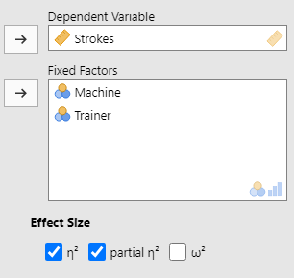
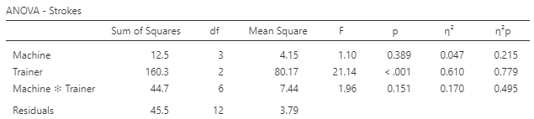
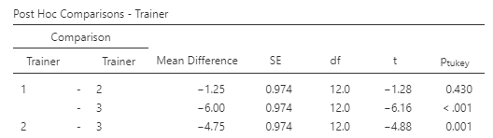

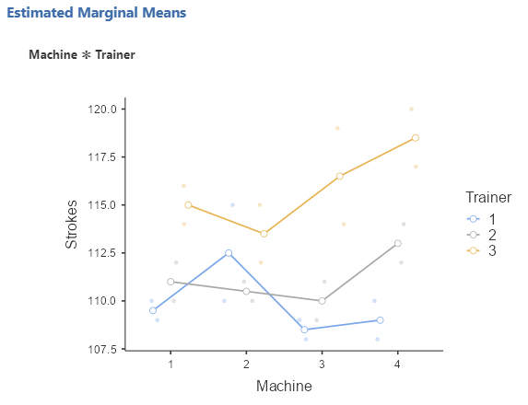

The ANOVA results show that the number of rowing strokes differs based upon the trainer (the p value is lower than 0.05). Moreover, this has a very large effect size at 0.779. Since there are three trainers, a post hoc test may be useful: trainers 1 and 3 as well as 2 and 3 have significantly different effects on breaking strength. As shown in the plot, trainer 3 appears to elicit the highest rowing performance on all of the machines..

Mixed ANOVA
In this (completely imaginary) study, we want to see differences in clinical reports, dependent on the stage of therapy (Injury 1 is at the beginning; Injury 2 is at an intermediate stage; Injury 3 is towards the end of treatment), and the type of exercise machine. Below are the results (also on the Mixed ANOVA.csv file):
Patient | Injury | StairClimb | Rowing
1 | 1 | 23 | 24
2 | 1 | 24 | 23
3 | 1 | 25 | 28
4 | 2 | 30 | 38
5 | 2 | 28 | 36
6 | 2 | 26 | 35
7 | 3 | 31 | 34
8 | 3 | 32 | 36
9 | 3 | 29 | 39

Conduct a mixed ANOVA with JASP and identify which factors are associated with clinical outcomes.

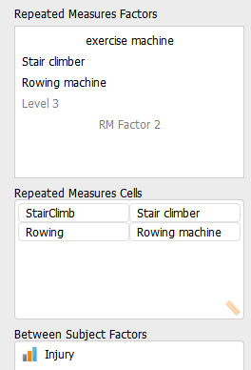
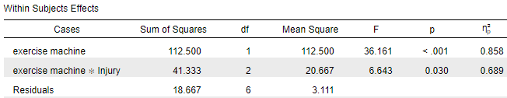

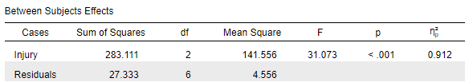

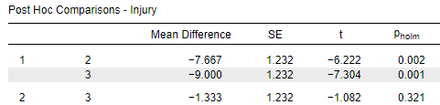

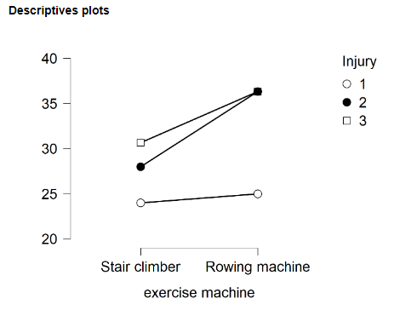

The within subject and between subject effects are both significant, as is their interaction. Moreover, they have large effect sizes (partial eta squared has been used). The post hoc tests indicate differences between injury stages 1 and 2, and between stages 1 and 3.
The descriptives plot shows that on both types of exercise machine, injury stage 1 produces the lowest average score. Injury stage 3 has a higher average score than injury stage 2 on the stair climbing machine but there was no clear difference between them on the rowing machine.

