Chapter 12
MANOVA
Using the High Jump.csv dataset, instead of treating limb injuries ('ArmLeg') as a covariant (as in the ANCOVA exercise), analyze it as a separate dependent variable. Thus, use MANOVA to evaluate if limb injuries and Training provision differ significantly per jump technique.
Check the assumptions before reporting the results but for simplicity, report the results 'as is' even though some assumptions may be violated. No data transformation will be conducted.
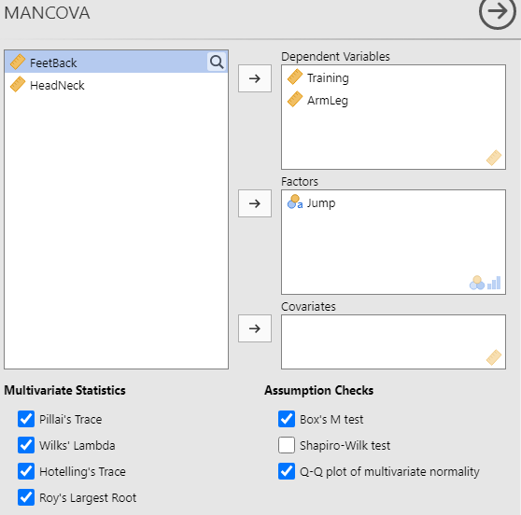

Box's Homogeneity of Covariance Matrices Test
χ² |  | df |  | p
58.9 |  | 6 |  | < .001

Q-Q Plot Assessing Multivariate Normality
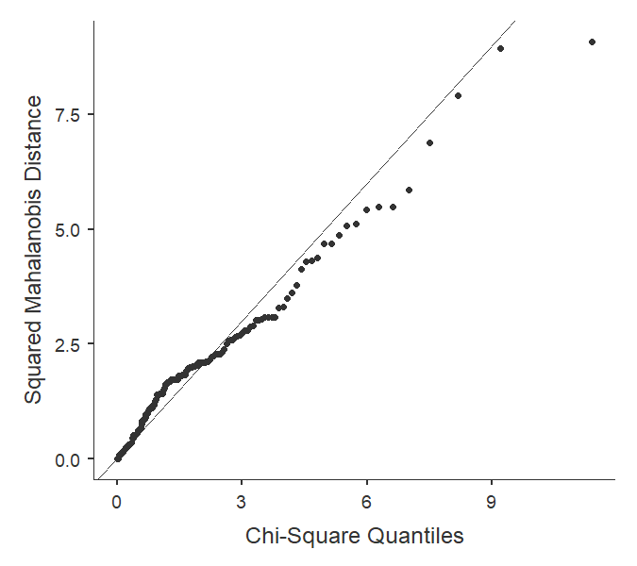

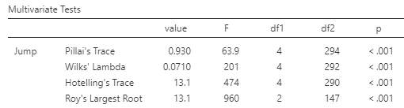
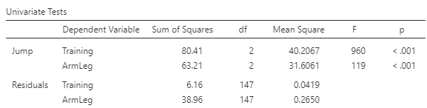
What do the assumption tests show?
Both sphericity and normality assumptions were not met.

What does the MANOVA show?
The multivariate analysis is significant (p <.001) showing that at least one of the two variables differs between the jump techniques. Looking at the univariate results, both training provision and limb injuries have significantly different mean values among the high jump methods.

