Descriptive Statistics
Exercises for central tendency and dispersion
Open the Height and Weight Data.csv file in Jamovi. Make sure that you edit the variable name, description, and data type properly.
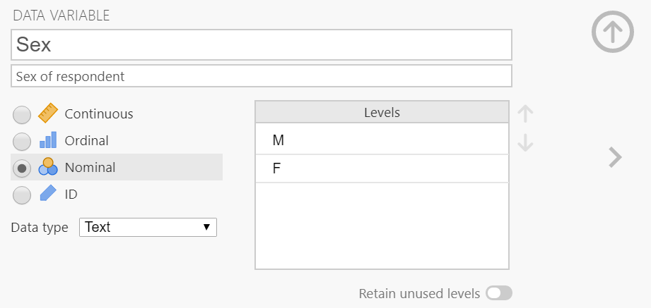
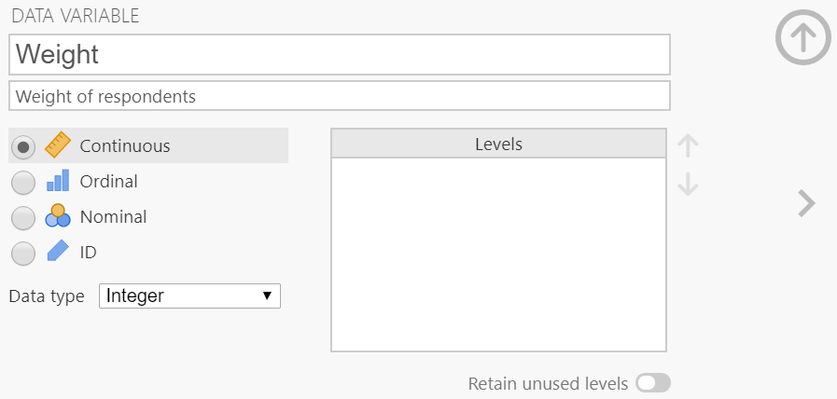
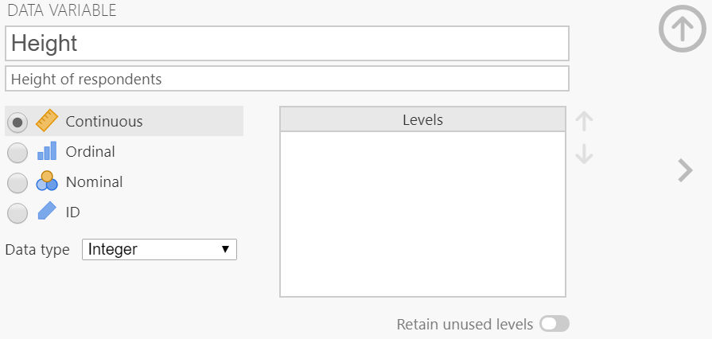
- Calculate descriptive statistics (mean, median, mode, range, missing values) for two variables, height and weight.
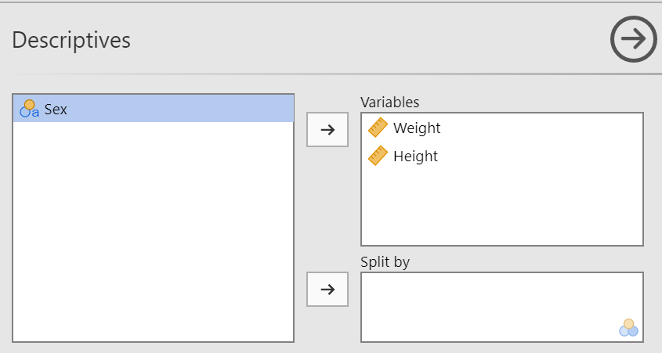
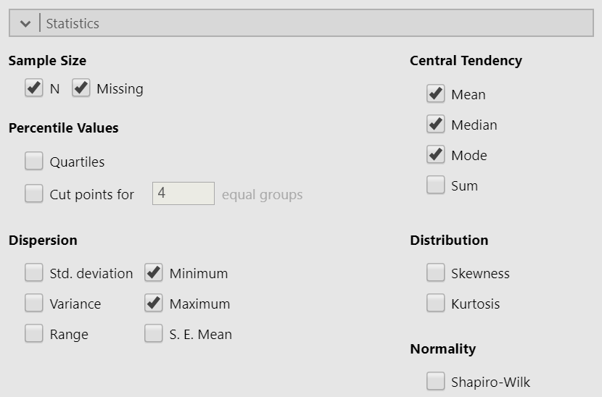
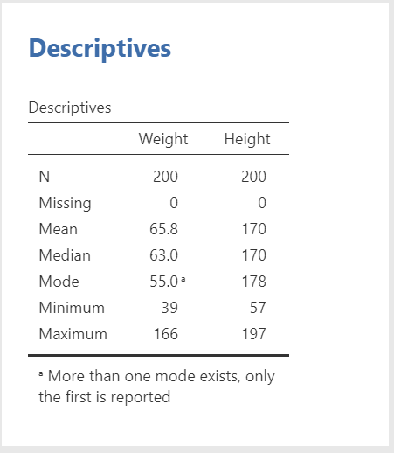
- Split the data by 'Sex' and calculate the same descriptive statistics
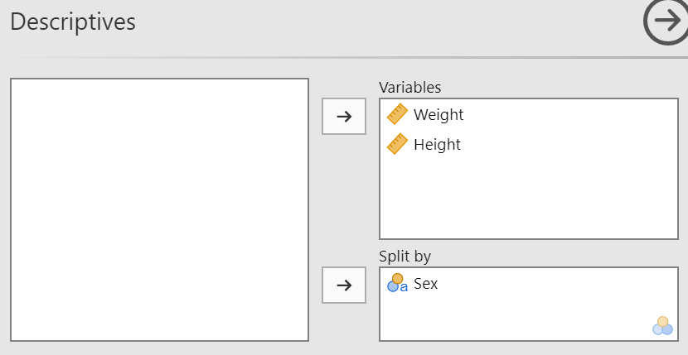
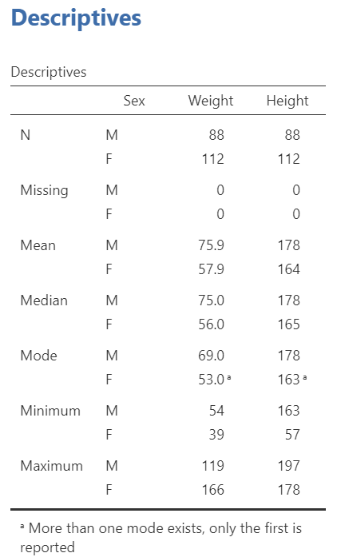

- Produce a histogram for the height and weight variables and decide if the distribution shapes resemble that of the Gaussian distribution.
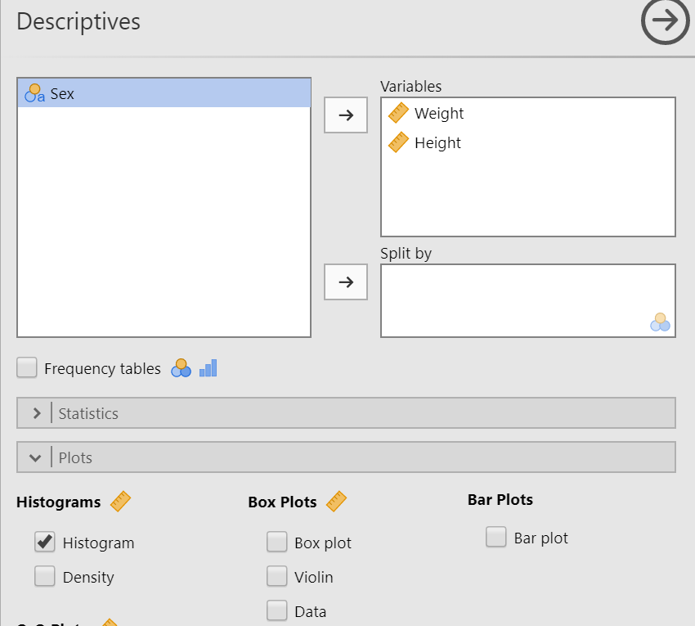
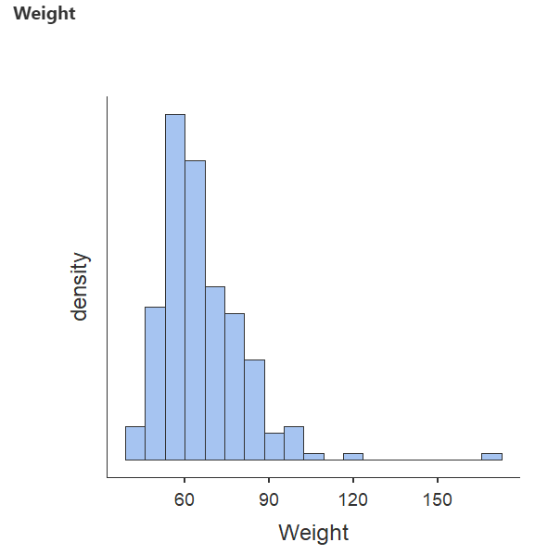
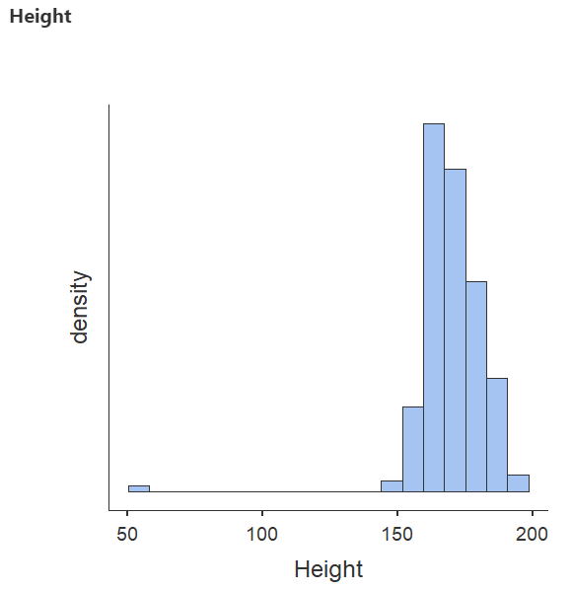
These do not resemble a Gaussian distribution.

